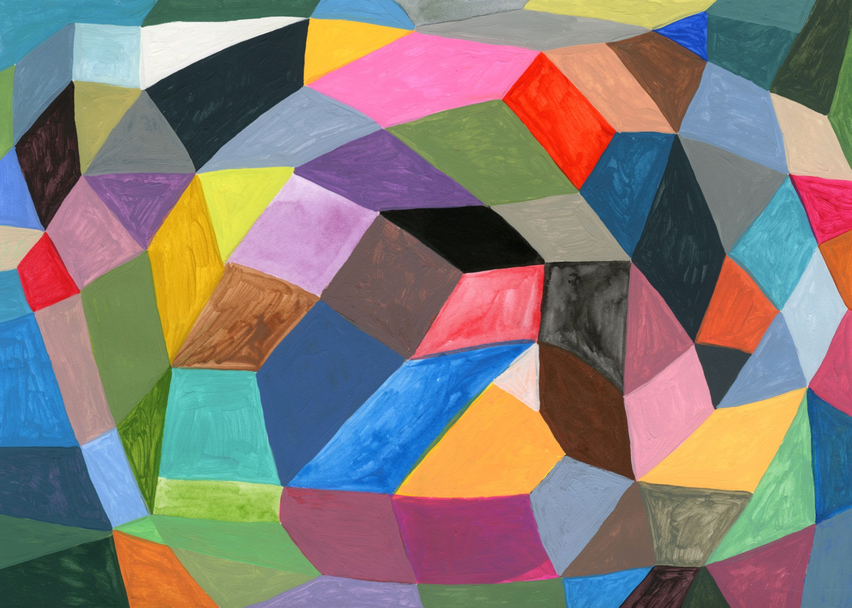

1.Create Logo(Canva).

2.Buy a domain/Hosting.(Truehost kenya/Hostinger).

3.Choose how to build website.(no code/code)

4.Prepare content.(Images,Certificates,testimonials)

5.SEO & Google Business.(Set up Google Business Profile.